PART 1: Creating Entity Classes:

1. The Entity framework object model can be created as a class library so that it can be reused in different apps
2. Create a class library using VS 2022

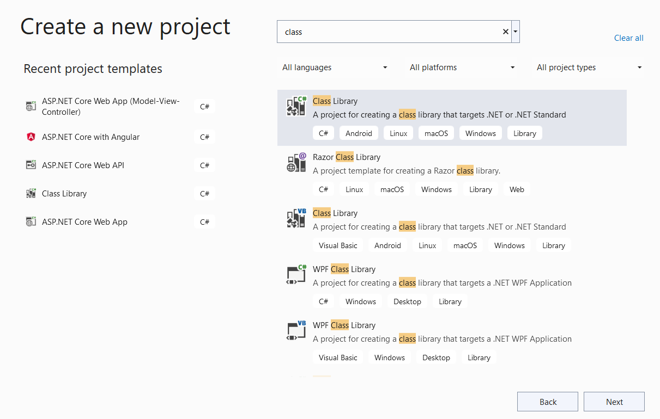

1. Name the project as ShoppingApp.EntityModelLibrary

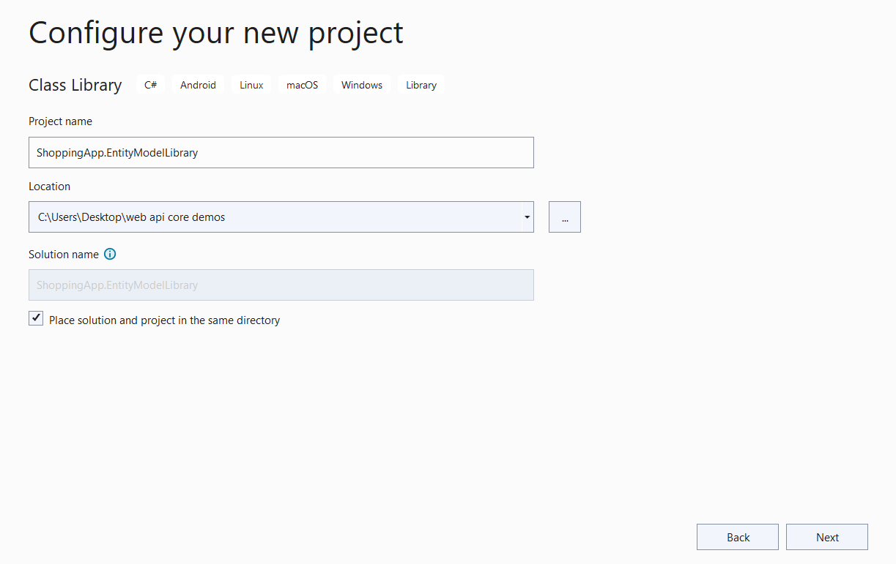

1. Select the framework as .NET Core 3.1
2. Right click on the project in Solution Explorer, select **Manage NuGet Packages** from the context menu. Install **Microsoft.EntityFrameworkCore** 5.0 and **Microsoft.EntityFrameworkCore.SqlServer** 5.0 . once the installation is done, the packages will appear in Solution Explorer:

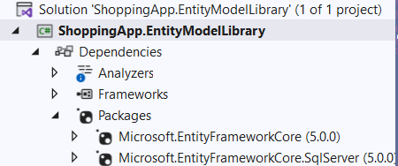

1. Rename the Class1 class to Product. Add one more class to the project and name it Category
2. Modify the Product and Category classes as shown in the following code:

public class Product

{

public int ProductId { get; set; }

public string ProductName { get; set; }

public int Price { get; set; }

}

public class Category

{

public int CategoryId { get; set; }

public string CategoryName { get; set; }

}

1. We have 2 classes with their properties defined. The next step is to understand the relationship between them: one category is linked with many products. One product is linked with only one category. To model the relationship, modify the Product and Category classes as shown below:

public class Category

{

public int CategoryId { get; set; }

public string CategoryName { get; set; }

public List<Product> Products { get; set; } // because one to many relationship

}

public class Product

{

public int ProductId { get; set; }

public string ProductName { get; set; }

public int Price { get; set; }

public Category ProductCategory { get; set; } // because of 1 to 1 relationship

}

Build the application.

PART 2: Creating Context Classes:

1. Add one more class to the class library, name it as ShoppingContext.
2. Modify the context class as shown below:

public class ShoppingContext: DbContext

{

public DbSet<Category> Categories { get; set; }

public DbSet<Product> Products { get; set; }

protected override void OnConfiguring(DbContextOptionsBuilder optionsBuilder)

{

optionsBuilder.UseSqlServer(

@"Server=CDC2-L-2JNVYW2;Database=shoppe;Trusted_Connection=True");

}

}

Note: the server and database values must be replaced with the server name and database name of your PC.

1. Build the application